**FUNDAMENTALS OF DATABASES – WEEK 3 – ACTIVITY 1**

Supply/perform what is asking in the following statements. Attach or put a screenshot for each number to support your answers.

1. Search a website or install a free software (for those who have laptop) which can be used as example of different types of interfaces for database or data management in the software/system.
2. Capture or make a screenshot for each types of interface given below and briefly explain its importance or benefits to the users.
   1. Menu-Based Interface
   2. Forms-Based Interface
   3. Graphical User Interface
   4. Natural language Interface
   5. Speech Input and Output
   6. Interfaces for DBA

a. **Menu-Based Interface** - The menu-based interface can make the navigation easier to the user, with just one click can show the different options the user can choose from.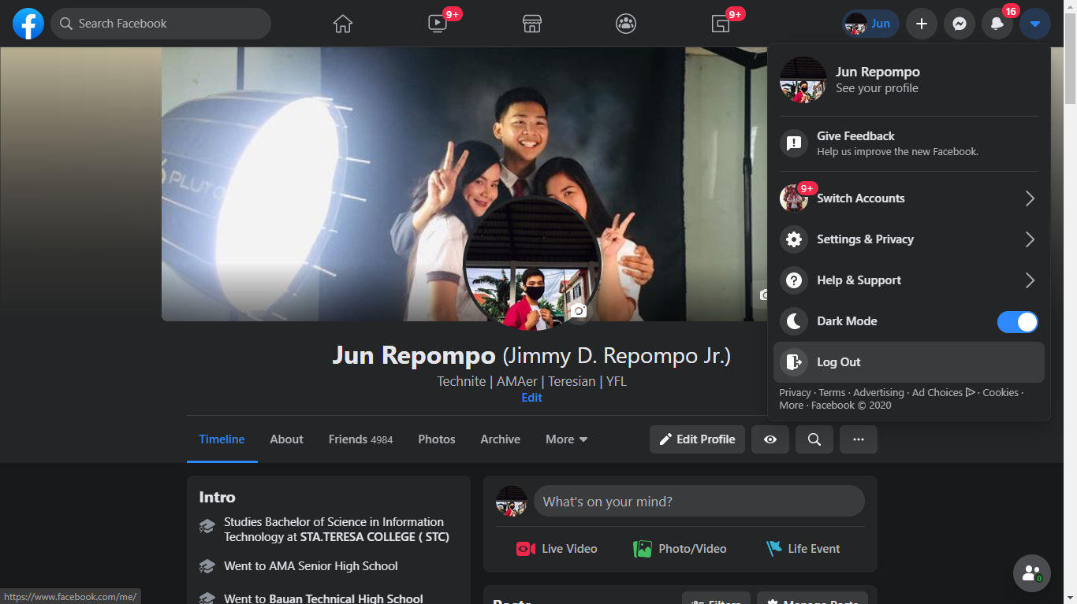

b. **Forms-Based Interface –** The form-based interface can make registering easier by using forms, unlike before where the user must use command line interface to register itself on the database.

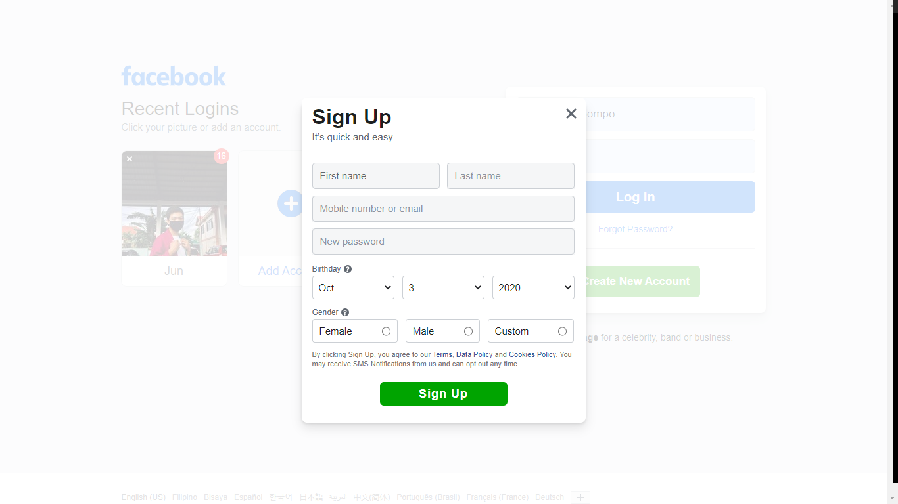

c. **Graphical User Interface –** The graphical user interface makes manipulating data much easier and friendlier to the user. With just one click at a graph or table, it can be easily manipulated or changed.

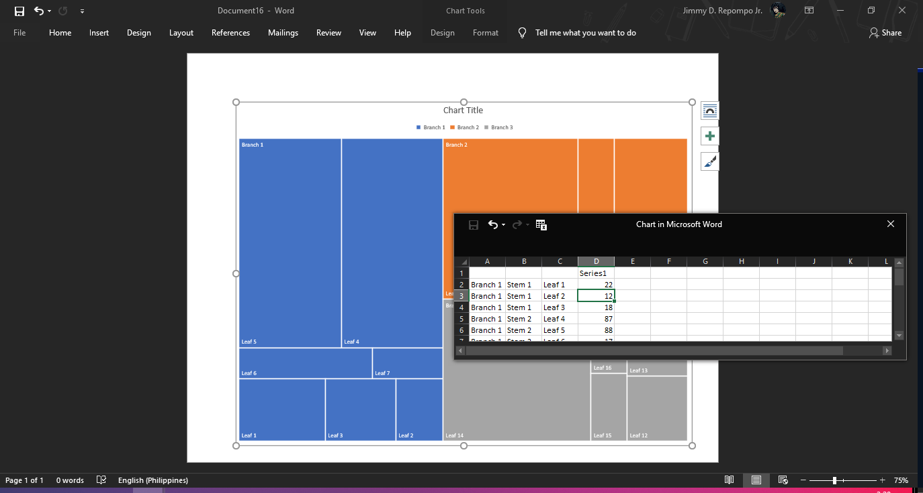

d. **Natural Language Interface** – The natural language interface takes time and much learning to use. It is much precise to others, but also can destroy data if manipulated incorrectly.

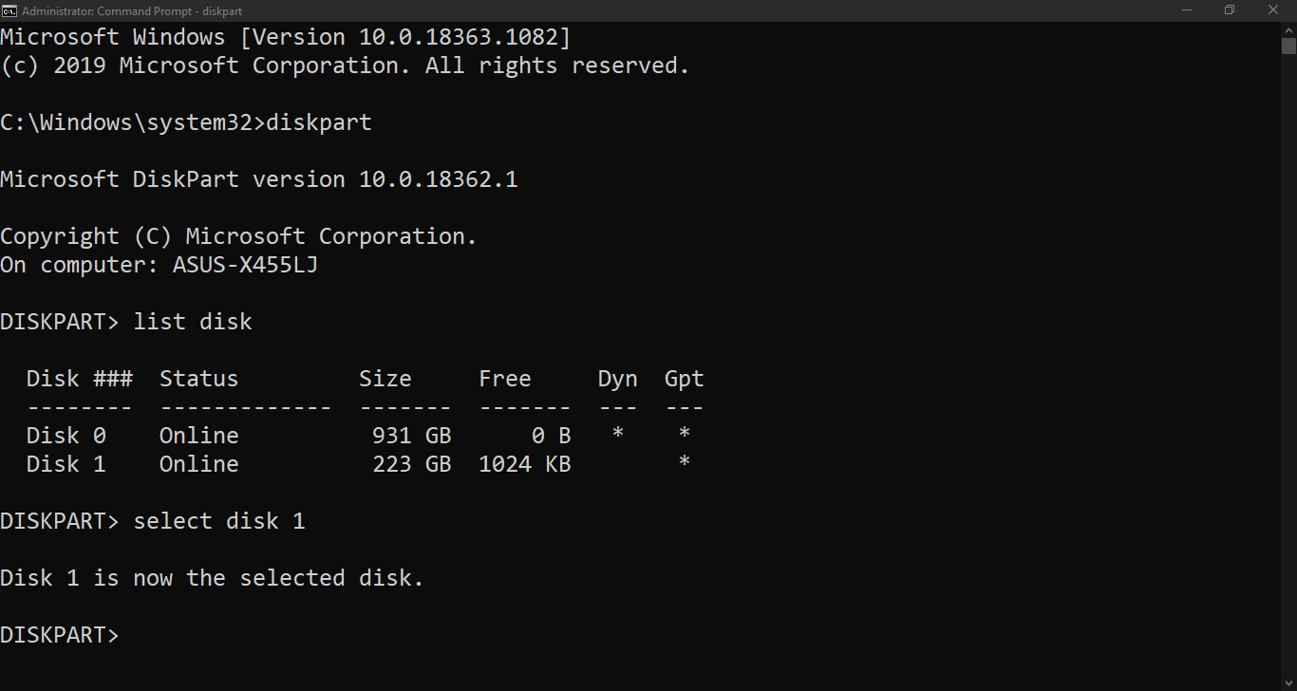

e. **Speech Input and Output** – The speech input and output can be the easiest way to do tasks, with just a press of a button or a magic word such as “hey google”, “hey cortana”, “hey siri”, they can easily make tasks for you such as creating reminders, search everywhere, and making an alarms for you so you don’t miss out any special event or occasion.

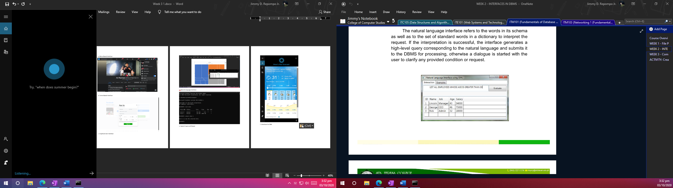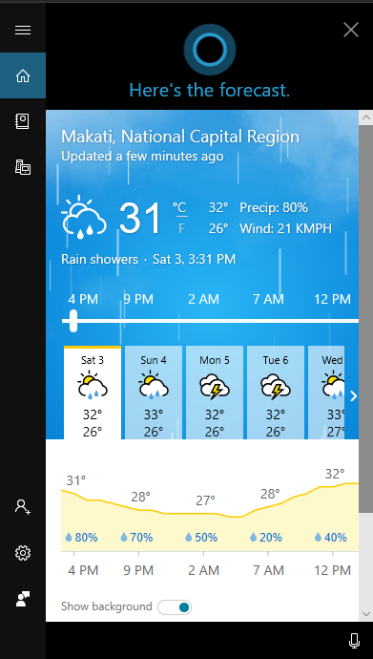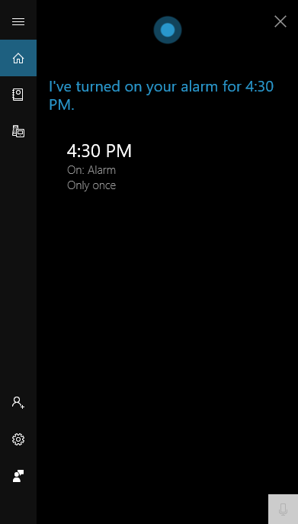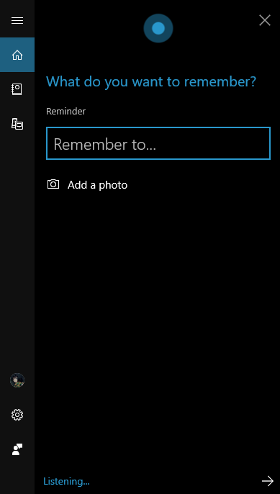

f. **Interfaces for DBA** – The interfaces for DBA is the best interface for administering the data inside the database system, and also it can grant accounts to be authorized so they can change the insides with a permission of the admin.

